

  - User Manual

  - Lakeland Electrical Ltd

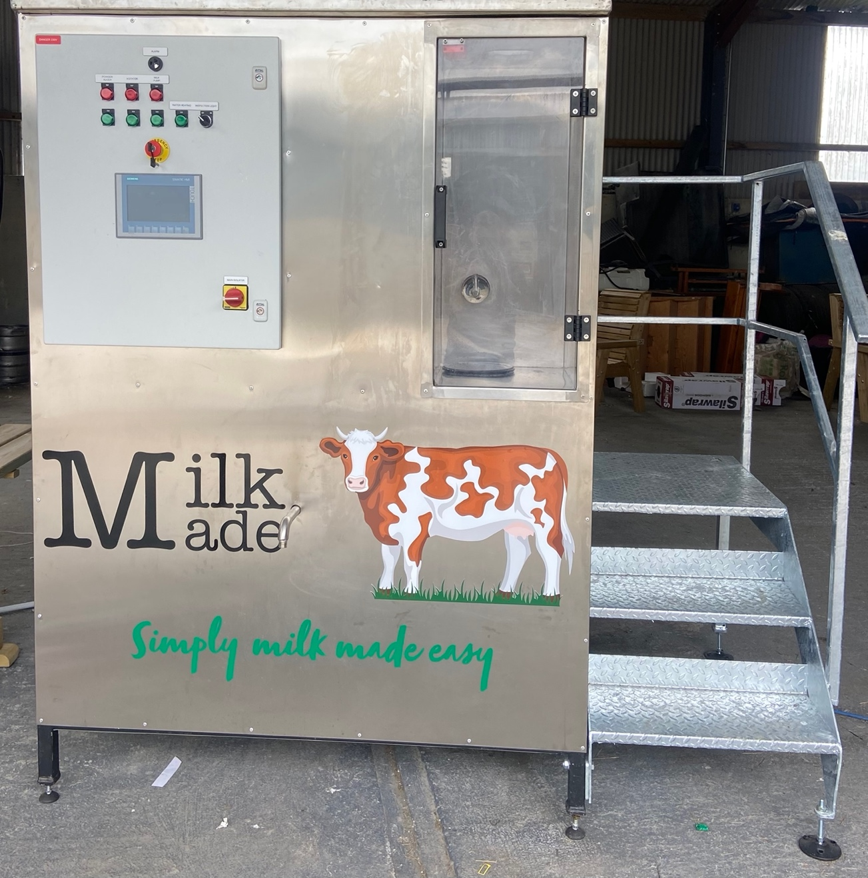
Milk Made User Manual

  - Milk Made
  - Copyright © 2022
  - Email: Lakelandelectrical@gmail.com

  - Date of manufacture: _________________
  - Serial number: _____________________

Table of contents

Welcome 1
Login 2
Home Page 3
Initial Set Up 6
Cleaning 9
Custom Cleaning 13
Inputs/Outputs 14
Parameters 16
Appendix 19



Welcome
We are delighted to welcome you to the new advancements in calf feeding. Milk Made is a state-of-the-art machine, manufacturing milk to an industrial level of quality. With just the press of a button, you can dispense perfectly blended milk within minutes. Users can customise their Milk Made experience using this booklet. Users can learn to adjust the working processes of Milk Made to follow their own personal recipes and quantities. Milk made eliminates the labour in calf feeding, so you can spend your time more efficiently.

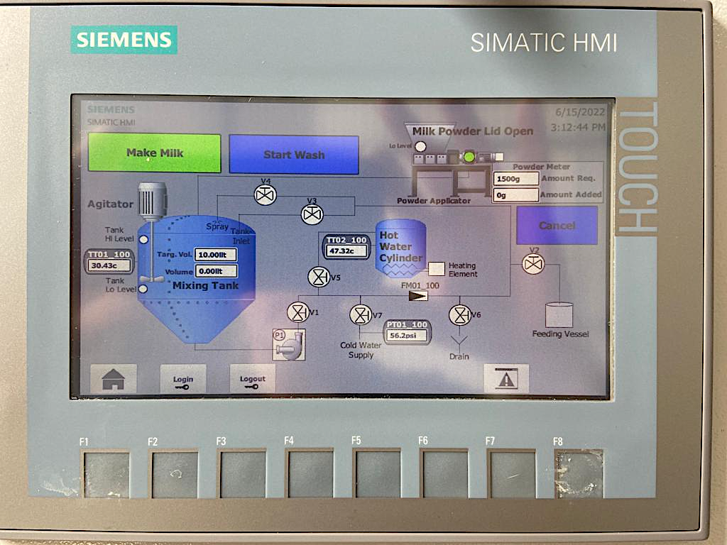
Login
Welcome to the homepage of Milk Made. Should the user wish to alter the default settings of the machine, they must login as shown below.
User: Engineer
Password: Eng2500
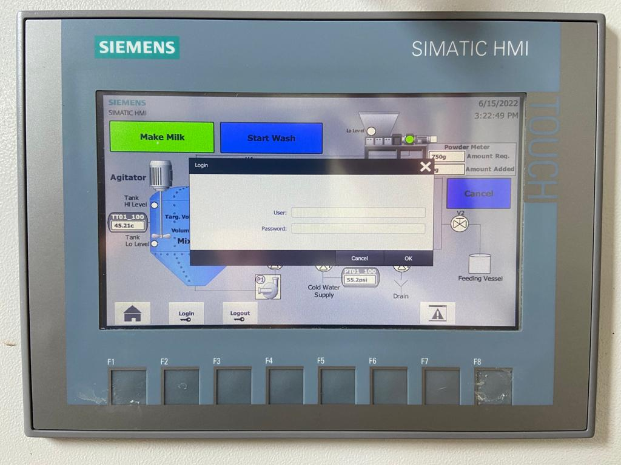
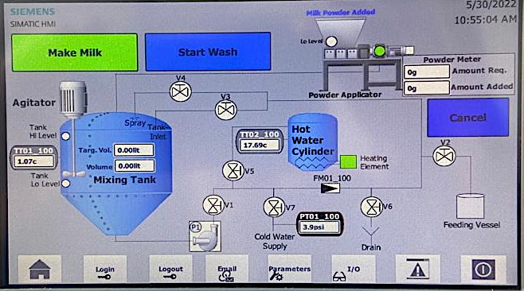
Eng2500
Engineer
The user opens the login box by tapping the “login” button. The user inputs the above login details and presses the “ok” button. This will reveal the bar highlighted in the adjacent image.

Home Page
Welcome to the home page of Milk Made. This page will guide you through the entire milk manufacturing process from powder to milk. To begin, tap the “Milk Made” tab as shown below.



This allows the “Select Batch” option to appear. The user can select either “Batch 1” or “Batch 2” as shown below. This will begin milk production.

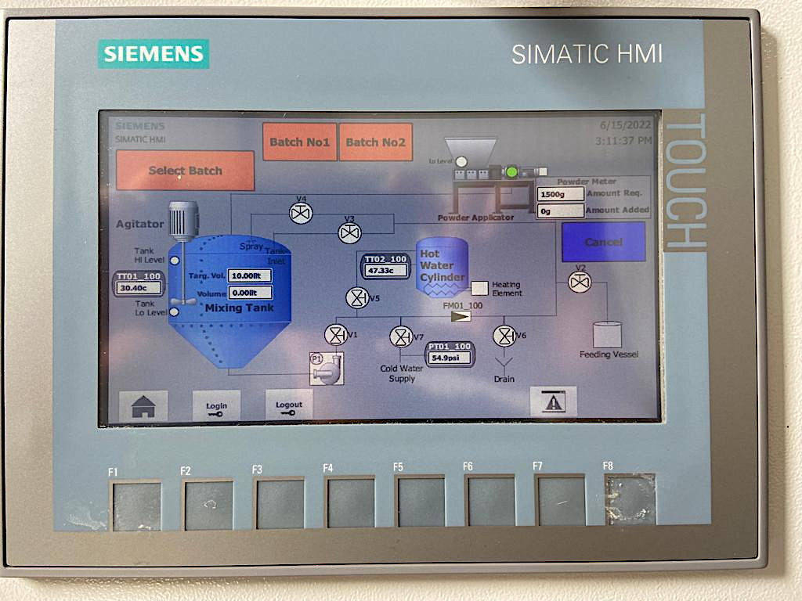







To begin, the machine dispenses the requested quantity of milk powder from the hopper into the augur. The user can monitor this dispense through the powder meter values displayed. When all requested powder has been dispensed, the amount requested value becomes equal to the amount added value.

On complete addition of powder from the augur into the mixing tank, the machine will begin to introduce a mixture of hot and cold water. This addition can be monitored by the user through the displayed target volume and volume values. When the target volume is equal to the volume value, the machine will no longer add water to the tank.

The agitator will begin to blend the milk powder and water into a smooth consistency. The milk is now ready to be dispensed by the user.
Milk Dispense
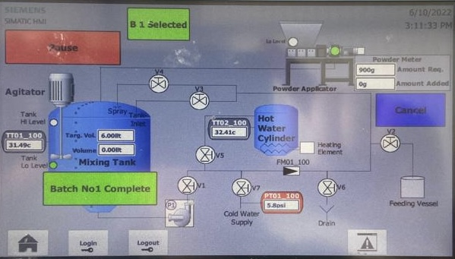

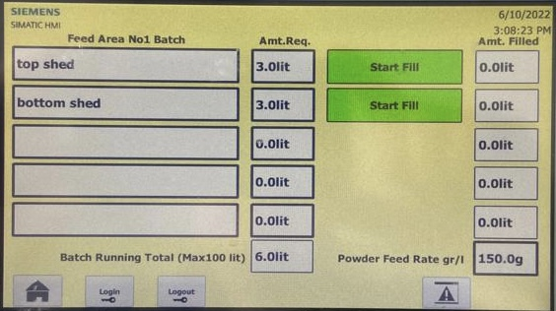
When the machine has completed milk production, the user can begin to dispense by pressing the tab as above.

This will redirect to the above page where the user can dispense each feed area into a feeding vessel by tapping the tab as above.
Initial Set Up
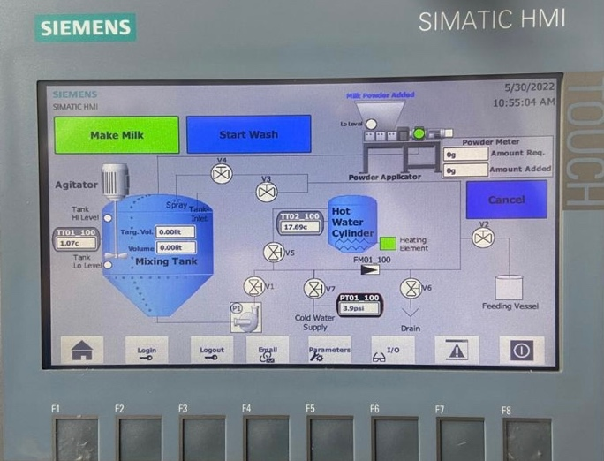
To begin making milk, it is important to set up batch one and two. This will allow the user to input their desired volume of milk and preferred milk concentration. This gives the user the option to run two different recipes on Milk Made.

To set up batch one, the user presses the “F1” button as shown. This will redirect to the following image.

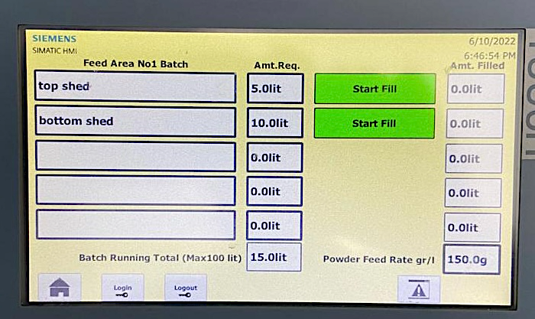

This page provides the user the opportunity to assign chosen quantities of milk to a specific name. For example, the first box “Top Shed” has been assigned 5 Litres of milk. The second box “Bottom Shed” has been assigned 10 Litres of milk. The user can assign up to 5 areas on this page, with each area following the same milk concentration.

Milk concentration for these 5 areas can be set by inserting desired quantity of powder per Litre into the Powder Feed Rate gr/l box, located in the bottom right of this screen.

The user can repeat these steps for “Batch Two” by pressing the “F2” button to redirect to the screen below.
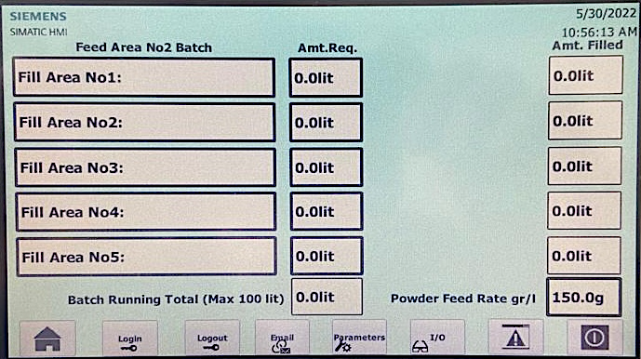

On completion of batch one and two set up, the user can now produce milk using two milk recipes for up to 5 areas in each recipe. The purpose of this design is to facilitate handover between users, ensuring each feed area receives the correct quantity of milk, in the correct recipe, at every feed.
Cleaning
When the user has completed milk manufacturing, it is important to initiate cleaning regimes to maintain milk quality. The user can begin this process by tapping the “Start Wash” button on the home page as seen below.

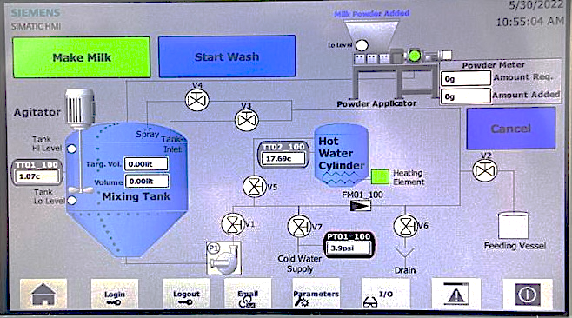

This redirects the user to a new page where they can initiate a rinse or full wash. We advise users to conduct a rinse after each feeding and a full wash weekly.

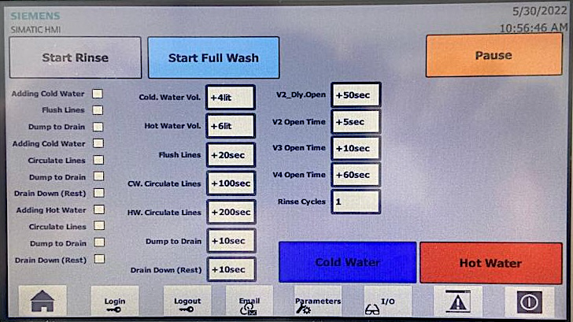

In pressing the grey button as shown above, the machine will begin a rinse cycle. The user can monitor this cycle on this screen. A rinse cycle begins by adding cold water to the system and ends before the hot water addition step.

In pressing the light blue “Start Full Wash” tab, the machine will begin with a rinse as above and continue the cycle through hot water addition to finally “Drain Down (Rest)” as shown above.

The user can monitor the rinsing or full wash process through the image below.

The rinse and full wash cycle commence in the same way. They begin by adding cold water into the mixing tank and system, circulating through the system before emptying to drain. It continues this process through the lines, emptying to drain. This completes the “Rinse” cycle. In conducting a “Full Wash”, the machine will proceed to add hot water after the rinse cycle and circulate it through the system before emptying. Users have the opportunity to include cleaning agents e.g. caustic in this step to enhance the cleaning process. As the machine begins each step, the adjacent white box will turn green and later returns to white on completion of this step.

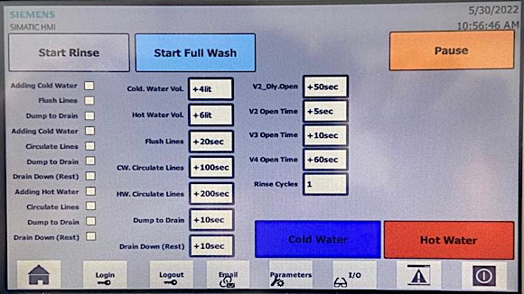

Should the user require the machine to dispense cold water only, they can do so by pressing the blue “Cold Water” button as shown.

Should the user require the machine to dispense hot water for other purposes, they can do so by holding down on the red “Hot Water” button for 5 seconds as shown. This is a safety mechanism to prevent accidental dispense of hot water.
Custom Cleaning
The user has the option to alter the cleaning processes by adjusting the following steps:

Time allowed for wash spray cleaning mixing tank
Time allowed for emptying to drain

Time allowed for first rinse to clean tank and pipes
Time for cold water to circulate/spray in tank and pipes

Time for hot water to circulate/spray in tank and pipes

Volume of hot water added during “Adding hot water”

Volume of cold water added during “Adding cold water”

Time allowed for draining of tank and pipes
Delay time to clean filling nozzle
Cleaning time of filling nozzle
Filling pipe clean time
Number of times cold water rinse cycle will repeat during “Rinse” and “Full Wash”

Inputs/Outputs

If the user wishes to monitor the machines current status at any time, the user presses the I/O tab as shown above. This will redirect the user to the below page outlining input activity. Should the user wish to review output activity, press the tab “Page 2” as shown below.

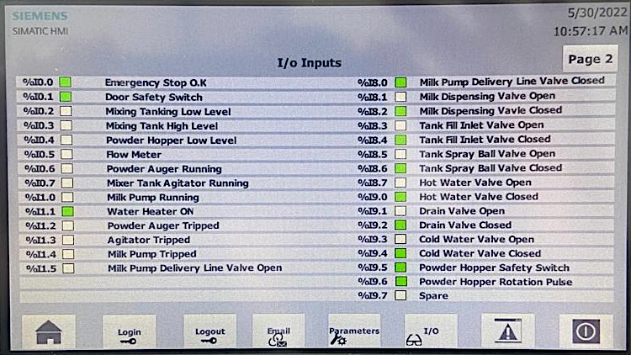

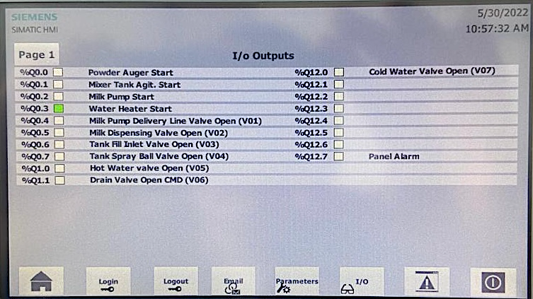

This page outlines the current status of varying components of the machine. Each component is accompanied by an adjacent box. This box will change colour to indicate activity and faults as follows:

Inactive

Active

Fault

Parameters
If the user wishes to adjust the general settings of Milk Made, press the tab “Parameters” as shown below.

This will redirect the user as per below
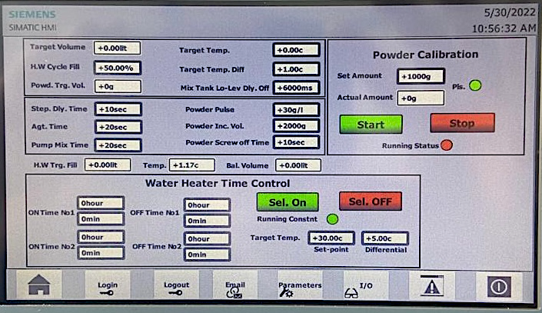









Percentage of hot water in tank before adding of powder
Time between programme steps
Agitator run time
Pump mix time before “batch ready” displayed
Desired milk temperature (default 40 degrees)
Milk temperature differential
Pump run time after mixing tank low level reached
Grams of powder per auger revolution
Powder volume adding increments
Time delay between adding of powder increments
This setting enables user to review calibration of machine by dispensing set amount. As the machine has complete dispensing, the set amount should be equal to the actual amount. The user can verify the actual amount using external tools to ensure the machine is performing correctly.

The time control feature enables users to schedule water heating twice daily. They can do so by inserting the preferred-on time e.g., 15 hours and 15 mins equates to 3.15pm. They can determine the duration of water heating by scheduling an off time e.g., 16 hours and 0mins would allow an overall water heating duration of 45minutes. The user can repeat the above steps for “ON Time No2” to enable water heating for a second duration during the same day. Target temperature value allows user to set desired temperature of water in hot water cylinder.

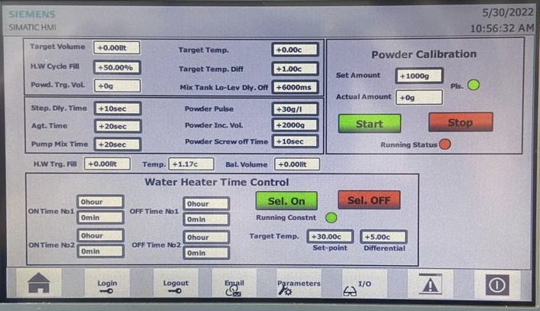
Select off ceases all hot water heating
Select on allows constant hot water heating

Appendix
TTO1_100 | Temperature probe in mixing tank
TT02_100 | Temperature probe hot water cylinder tank
PT01_100 | Pressure sensor cold water supply
FM01_100 | Flow meter
I/O | Inputs Outputs
Targ Volume | Target volume i.e., amount of milk machine intends to produce
Amount Req | Requested quantity of powder to be added during milk production
Powder Feed Rate gr/l | Grams/Litre determining milk concentration

Milk Made
Lakeland Electrical Ltd

